Pressure and Temperature
Demonstrate the effects of temperature on pressure by making water rise against gravity.
Difficulty | Excitement

Materials
- A 1000 mL Erlenmeyer flask with a mouth of approximately 1.5” diameter (other similar shaped glass containers should work),
- A candle that is 2–5” tall and 1” or less in diameter,
- Matches or a lighter,
- A small plate,
- Food coloring,
- Clay or Play-Doh.
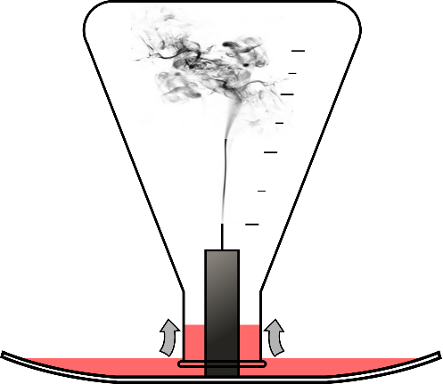
Procedure
- Place the candle upright in the center of the small plate. Clay or Play-Doh may help the candle to stay upright.
- Pour a layer of water onto the plate, dying the water with food coloring so that it is easier to see.
- Light the upright candle.
- Carefully place the Erlenmeyer flask upside-down onto the plate, making sure that the candle fits through the neck of the flask. Watch the candle flame go out, and the water rise up into the flask.
What Happened?
Putting the flask over the candle suffocated the flame, as it quickly used up all of the available oxygen. Without the flame, the temperature inside of the warm glass started to rapidly decrease. As the temperature of the air inside of the beaker drops, the pressure decreases as well, and is now lower that the pressure outside of the beaker. The water then flows from high to low pressure and rises slightly inside of the beaker.
Why is This Important?
This principle is important for understanding how pressure and temperature are related and how gasses and liquids move. These concepts are important for many scientific and engineering fields.
Atmospheric Sciences – This concept is important for predicting the weather and determining air and water movement around various terrains, such as mountains and valleys.
Geology – It is important for understanding how air, water, and magma move on and in the earth, which help create many geological formations.
Metallurgical Engineering – It is important for understanding how molten metals and chemical solutions move, which is important for metal refining and making new metal alloys.
Mining Engineering – It is important for predicting how slurries containing small particles of ore move. Slurries can be used to transport ore and keep machinery cool to prevent overheating.
Basic Concepts Learned
- The temperature and pressure of a gas are related. As the temperature decreases, the pressure does as well.
- Liquids and gasses move from high low pressure.

