Bernoulli’s Law – Example 1
Demonstrate an unusual property of Bernoulli’s Law with a simple experiment.
Difficulty | Excitement

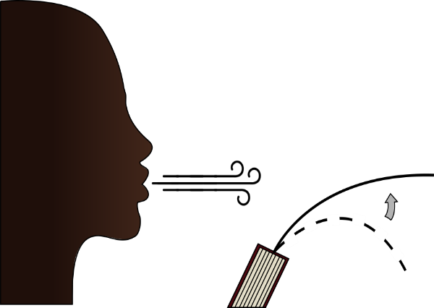
Materials
- A book
- One half-sheet of paper (approximately 4” x 11”).
Procedure
- Insert the piece of paper into pages of the book, leaving most of it sticking out, as shown.
- Blow across the top of the piece of paper.
  - The piece of paper should rise.
What Happened?
The piece of paper rose even though we were just blowing across it. This occurs because of a Bernoulli’s Effect. Bernoulli’s Law states that fast-moving air has lower pressure than slow-moving air. The air was moving faster over the top of the paper, so there was a lower pres sure on the top side of the paper. The air around the paper moves from high to low pressure, pulling the piece of paper upward.
Why is This Important?
This principle is important for understanding how gasses and liquids move, which is important for many scientific and engineering fields. This is the same principle that keeps airplanes aloft. The air moves faster over the top of the wing, which lowers the pressure and pulls the airplane upwards.
Atmospheric Sciences – This concept is important for predicting the weather and determining air and water movement around various terrains, such as mountains and valleys.
Geology – It is important for understanding how air, water, and magma move on and in the earth, which help create many geological formations.
Metallurgical Engineering – It is important for understanding how molten metals and chemical solutions move, which is important for metal refining and making new metal alloys.
Mining Engineering – It is important for predicting how slurries containing small particles of ore move. Slurries can be used to transport ore and keep machinery cool to prevent overheating.
Basic Concepts Learned
- Bernoulli’s Law states that fast-moving fluids have a lower pressure than slow-moving fluids.
- This is an important scientific concept which occurs in many industries, as well as in nature.

